SUMMER FINALE !

BARBECUE

WHEN -
WEDNESDAY SEPTEMBER 20

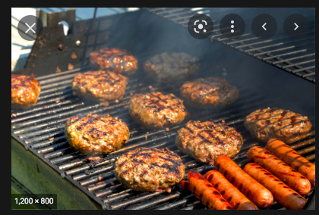
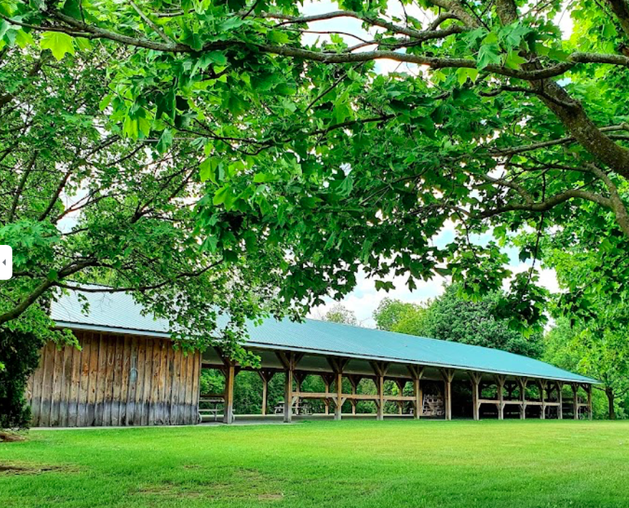
WHERE -CULLEN CENTRAL PARK, WHITBY…… 4015 Cochrane St. ,

TIME -1:00 pm lunch
(park reserved for us
10: 00 am -7:00 pm)

COST- ? pp

MENU - choice of burger or sausage, potato salad, Caesar salad, dessert, drink
Must select choice of burger or sausage at sign up
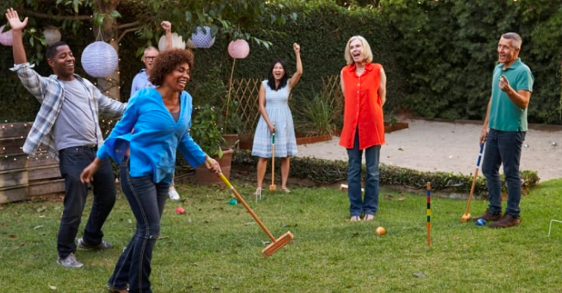
(veggie burger available on request)

WHAT TO DO:
- paved walking trails
- croquet
- bocci ball
- soccer ( for the brave & foolish?)
- badminton
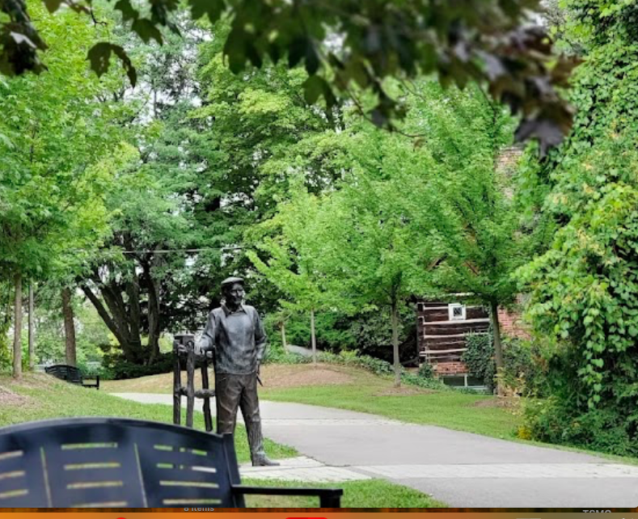
-public pickle ball courts available
( first come, first served)
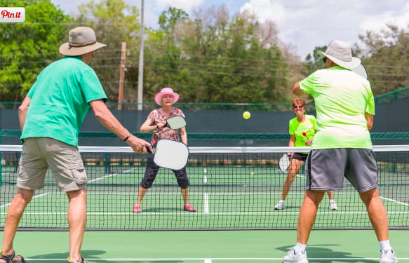
- watch the players, sit and chat !

car pooling available- sign up if need ride

sign up at social table or at a meeting or by email to ..social.uxbridgprobus@gmail.com …
or by telephone to Gail Heroux ..905-852-9927 or Camille Scarlett..416-859-1593

